**Improving Patient Experience in the Outpatient Facility of a Hospital Using Beacons**

**Jude Crispo Kikuyu**

**089722**

**Submitted in partial fulfilment of the requirements of the Degree of Business Information Technology at Strathmore University**

**Faculty of Information Technology**

**Strathmore University**

**Nairobi, Kenya**

**May 2018**

**Declaration Statement**

I declare that this work has not been previously submitted and approved for the award of a degree by this or any other University. To the best of my knowledge and belief, the research proposal contains no material previously published or written by another person except where due reference is made in the research proposal itself.

Student Name: Jude Crispo Kikuyu

Sign: _________________________________________

Date: _________________________________________

**Approval**

The Information System Project 2 proposal of Jude Crispo Kikuyu was reviewed and approved (for examination) by:

Supervisor’s Name: Kevin Ochieng’ Omondi

Sign: ________________________________________

Date: ________________________________________

**Acknowledgements**

I extend my thanks to my project supervisor Mr. Kevin Omondi who critically examined my proposal and made suggestions and comments that greatly improved it. The University has provided modern facilities that have allowed me to prepare and develop my project and for this I am grateful. Lastly, my family who have been patient with me and have continually supported me by giving me the required space to concentrate and conclude this project.

**Table of Contents**

Chapter 1. Introduction 1

1.1. Background of the Study 1

1.2. Problem Statement 2

1.3. Research Objective 3

1.4. Research questions 3

1.5. Scope 4

1.6. Justification/Significance of the Study 4

1.7. Limitations and Delimitations 5

Chapter 2. Literature Review 6

2.1. Introduction 6

2.2. Current Health System Challenges 6

2.3. Patient Centric Engagement 7

2.4. Leveraging on Bluetooth Low Energy (BLE) Beacons at health facilities 8

2.5. BLE Beacons Techniques and Technologies 9

2.6. Alternative Technologies to BLE Beacons in reducing patient wait time 10

2.6.1. Global Positioning System (GPS) 10

2.6.2. Wireless Fidelity (Wi-Fi) 11

2.6.3. Radio Frequency Identification (RFID) 12

2.6.4. Quick Response (QR) code 13

2.6.5. Long Term Evolution (LTE) Direct 13

2.7. The Best Approach for BLE Beacons Implementation using Tools, Techniques and Methodologies of Similar Systems 14

2.8. Architectural Design of the patient improvement using beacons 16

Chapter 3. Research Methodology 17

3.1. Introduction 17

3.2. Software Development Methodology 17

3.2.1. Conceptualization of the project 17

3.2.2. Inception phase 17

3.2.3. Construction 18

3.2.4. Release 18

3.2.5. Production 18

3.2.6. Retirement 18

3.3. Functional requirements 19

3.3.1. Beacon Frame Type Requirement 19

3.3.2. Beacon URL configuration Requirement 19

3.3.3. Authentication Requirement 19

3.3.4. Authorization Requirement 19

3.3.5. New User Requirement 19

3.3.6. Existing User Requirement 19

3.3.7. Patient request Requirement 20

3.3.8. Patient Preliminary Check Requirement 20

3.3.9. Payment Requirement 20

3.3.10. Queue broadcasting requirement 20

3.3.11. E-prescription requirement 20

3.3.12. Survey requirement 20

3.4. Non-Functional Requirement 20

3.4.1. Operational Requirement 21

3.4.2. Performance Requirement 21

3.4.3. Security Requirement 21

3.4.4. Cultural and Political requirement 22

3.5. System Implementation methods and tools 22

3.5.1. Software Tools 22

3.5.2. Hardware Tools 23

3.6. Deliverables 24

**List of Figures**

Figure 1: Patient Engagement (from Karanja, 2012) 8

Figure 2: Patient Engagement (from “ReferralMD,” 2018) 9

Figure 3: A BLE Beacon (from “Eddystone Beacon,” n.d.) 11

Figure 4: Global Position System (from Mahajan, 2015) 12

Figure 5: Wi-Fi Wireless LAN (from Bowden, 2015) 13

Figure 6: How RFID works (from “What is RFID?,” n.d.) 14

Figure 7: QR code (from Rouse, n.d.) 14

Figure 8: LTE Direct (from Triggs, 2015) 15

Figure 9: Conceptual design of the system 17

Figure 10: Agile Software Development Methodology 18

**Abstract**

The outpatient facility in a hospital or clinic is the first point of contact by people seeking medical help. People stream into the outpatient facility in their hundreds making this facility the busiest in the hospital. In most cases, the wait time or the time a person waits to see a Doctor is substantial and likely to place the person’s life in danger. Indeed, some people have died at the waiting area due to the extended time prior to seeing the physician.

The need to reduce the wait time thereby improving the patients experience is essential. Currently, the number of steps taken from filling in the admission form to paying a registration fee and initial blood pressure, weight and temperature check takes about 45minutes before one can see the doctor.

The proposed solution will show case the use of beacons as a way for reducing the time spent by patients in the outpatient facility. A visitor walking into an outpatient facility receives notifications on his smartphone using the Bluetooth facility of the phone. These notifications will allow the person to fill in a registration form, make payment by card, mobile money or cash, get updates of special offers, position in queue, doctor assigned to him and complete a survey. Thus, it is expected that the solution will reduce the time spent at the facility by half. The proposed solution will use agile methodologies as its development relies on participation and feedback from patients, hospital support staff, nurses and doctors.

**Keywords**: Beacons, Bluetooth, Notifications, Outpatient Facility, Waiting Time

**Abbreviations**

|  |  |
| --- | --- |
| 2D | * 2 Dimension |
| 3GPP | * 3RD Generation Partnership Project |
| AJAX | * Asynchronous JavaScript |
| BLE | * Bluetooth Low Energy |
| BP | * Blood Pressure |
| BTS | * Base Transceiver Station |
| CO | * Clinical Officer |
| CSS | * Cascading Style Sheets |
| D2D | * Device to Device |
| EID | * Ephemeral Identifier |
| GPS | * Global Positioning System |
| HTML | * Hypertext Markup Language |
| HER | * Electronic Health Record |
| IEC | * International Electrotechnical Commission |
| ISO | * International Standard Organization |
| KES | * Kenya Shillings |
| KHHEUS | * Kenya Household Health Expenditure and Utilization Survey |
| KNBS | * Kenya National Bureau of Statistics |
| LTE | * Long Term Evolution |
| MOH | * Ministry of Health |
| MRS | * Medical Record System |
| NFC | * Near Field Communication |
| NHIF | * National Health Insurance Fund |
| POC | * Proof of Concept |
| QR | * Quick Response |
| RFID | * Radio Frequency Identification |
| SDG | * Sustainable development goals |
| TLM | * Telemetry |
| UNDP | * United Nations Development Program |
| UID | * Unique Identifier |
| URL | * Universal Resource Locator |
| USA | * United States |
| Wi-Fi | * Wireless Fidelity |
| WLAN | * Wireless Local Area Network |

# Introduction

## Background of the Study

The number of outpatient visits has been steadily rising over the years. The barriers to outpatient visits included poor infrastructure making health facilities inaccessible, high cost of treatment, cultural or religious reasons and limited knowledge of health importance. These barriers have diminished over the years because of increase knowledge and devolution thereby resulting in an influx of patients to hospitals and clinics countrywide. According to a survey conducted by the Ministry of Health (MOH) and Kenya National Bureau of statistics (KNBS), visits to outpatient facilities increase by 90% in 2013 i.e. from 4.8 million to 9.1 million outpatient visits (*2013 Kenya Household Health Expenditure and Utilisation Survey*, 2014, p. 30).

Kenya has for many years desired to meet its health objective. The President’s Jamhuri day speech (“Speech By His Excellency Hon. Uhuru Kenyatta on Jamhuri Day,” 2017) included health in his big four plan. Therefore, in this year’s budget, 44.6 billion Kenya Shillings has been allocated to providing universal health coverage to all Kenyans (*Budget Statement FY 2018/19*, 2018, p. 23-24). This is in line with the sustainable development goals (SDG) that emphasize access to quality healthcare to all (“Sustainable Development Goals | UNDP,” 2015). Whereas the the Kenyan government has continued to prioritize health, it must use a different strategy from what has been used in the past.

Quality healthcare is part of the health reforms in Kenya. There are several aspects to quality healthcare such as accessibility of the health facility, availability of the Clinical Officers (CO)/Doctors, time spent waiting to see the CO, time spent with the CO, proximity of the health facility and technical skills. According to this study, time spent waiting to see the CO was rated poorly compared to all other aspects that were used to measure quality (Karanja, 2012, p. 150). Although it is a balancing act to cater for all these aspects of quality healthcare, the patient placed greater weight on the amount of time spent at the health facility. Time spent at the health facility need to be reduced by half to realize quality healthcare.

The outpatient facility is the first contact point of ninety percent of persons who visit the hospital seeking medical attention. Recently, there has been an influx in visitors to outpatient facilities mainly because of the outpatient cover offered by Kenya National Insurance fund (NHIF). This cover was introduced in July 2015 and provides outpatient cover at selected health facilities in the country to its members who are required to make a monthly minimum contribution of just five hundred Kenya Shilling (KES 500/-). Additionally, is the devolvement of healthcare resulting in increased funding for improvement of health facilities at the county. Therefore, outpatient facilities are receiving more visitors today and managing this increased volume will ensure costs are kept at a minimum and patient experience is enhanced.

The existing medical record system (MRS) is ill equipped to handle the influx in patients at the outpatient facility. First, the hospital systems were designed for capture patient data and this was done from a service station. Second, it wasn’t envisaged at that time that self-service systems would be more beneficial in capturing patient record. Third, as technology changed hospitals were unable to keep up mainly because of the high cost of adopting new technological solutions. Fourth, with advancement in technology and a knowledgeable society, demand for improved service delivery and privacy of data is taking center stage with individuals demanding to be in control of the own data while expecting high quality services. And so, to bridge this gap existing in the current MRS, a middle ware is necessary to link the existing system with new technologies.

There is a mobile penetration of over 88% placing Kenya at the top globally in the share of internet traffic coming from smartphones (“Kenya’s mobile penetration hits 88 per cent,” 2015). This simply means that close to about 39 million Kenyans has a Smartphone. Therefore, each patient streaming into a health care facility are likely to have smartphone in their possession. This device can easily benefit outpatient facilities through its use in carrying out tasks such as registration, payment of bills, directional information, appointment requests and invoicing that are currently being undertaken by under staffed registration departments.

While there may be initiatives to reduce the amount of time spent waiting to see a CO, such as registering patients as they arrive to see the doctor, promptly calling out the patient and directing them to different service areas, this approach is time consuming. An alternative solution is to make use of technology to engage with the patient. Patients are more likely to see a notification on their phone than to hear their name being called out simply because they are more engrossed on their phone than what is happening around them.

## Problem Statement

The amount of time spent at the outpatient clinic by a patient waiting to see a doctor is archaic and is a bottleneck in achieving quality healthcare at an affordable cost. Firstly, A person must present themselves at the registration desk give their admission number and for first timers fill out a registration form. This form is handed over to the attendant who must key in the data into the medical record system (MRS) and in case of someone who has an admission number, the record is retrieved from the database. In both cases the patient must wait for about 15 minutes. Secondly, payment must be made such as a registration or doctor’s consultation fee at the cash office and because there is a queue, the patient must wait another 10 minutes. Thirdly, the person still must wait for his vitals (BP, temperature weight) to be recorded and again wait to be examined by the doctor which is an additional 30 minutes. Finally, more time is spent in waiting for the drugs to be dispensed at the pharmacy resulting in the overall wait time at the outpatient clinic being about an hour. Notably, is the consistency with a study carried out (Wafula, R.B, 2016).

The MRS is either electronic or manual whichever the case it sole purpose is to capture or retrieve information regarding a patient. This type of system can only handle one patient at a time to interact with more patients at the same time, it becomes necessary to increase the personnel at the service desk and increase cost. Patient interaction with the system is absent thus reducing the transparency of what goes on behind the counter. Additionally, new technological advancement missing in these systems, yet it is possible to put a bridge between the existing and such new technology. Today, systems are meant to do more than capture, they act as a point of interaction with the user providing updates and useful information to help users make decisions.

## Research Objective

The aim of this research is to showcase a solution that utilizes Bluetooth low energy (BLE) beacons to provide notifications to smartphone devices that are Bluetooth enabled thereby allowing patients to carry out tasks such as registration, request to see a doctor, make payments, participate in a survey, receive e-prescriptions and doctor’s next appointment on their phones.

## Research questions

1. To investigate the bottlenecks the current system and what can to done to leverage on Bluetooth technology.
2. To analyze current techniques and technologies using BLE beacons
3. To determine if BLE beacons are the best option in reducing patient waiting time at outpatient clinics
4. To find the best approach to implement and use BLE beacons once determination is made of their viability
5. To investigate existing methodologies, tools and techniques that is used to develop similar systems.
6. To develop and test a middle-ware that can receive and transmit notifications and interact with existing systems.
7. To validate that the developed notification system does indeed reduce the patient wait time and improve patient experience at the clinic.

## Scope

The proposed solution shall be used with the outpatient center within the hospital/clinic and will be used to broadcast a notification that allows incoming persons to fill in a registration. The registration details will then be captured in the hospital’s database.

The approval of a registration will trigger a notification for request to make payment. Payment shall be done through third-party payment solutions such as M-Pesa that are already in the market. A notification will be received that contains the link to the receipt that can be downloaded. Additionally, an email containing the e-receipt shall be forwarded to the user’s registered email.

The user will receive notification containing his token number examination room for checking of vitals and another notification of next doctor available to be seen.

On completion of examination by the doctor, the patient will receive an e-prescription with cost of the for the drugs. In case of payment to be made, the payment process will be followed. Once paid, the pharmacy receives the prescription and patient collects the drugs. Additionally, the patient shall receive a notification to fill in a survey form to help improve outpatient services.

## Justification/Significance of the Study

The amount of time spent waiting to see a CO is costly both to the health facility and the patient. Also, the number of outpatient visits is growing on a yearly basis and a better approach to ensure quick and effective turnaround of patients treated is required. To manage several patients at the same time requires a solution that interacts with the patient to seek, process and return information to the patient.

New trends in technology that utilizes inexpensive Bluetooth for communication is available and implementation is cost effective. Using this technology empowers the patient by allowing them to carry some tasks and in the process frees the service desk for more important tasks. This also places the responsibility of time spent at the clinic on the patient. And patient can share the views through online surveys. All this is done using the existing infrastructure with minimal impact to the said infrastructure.

Currently, the existing systems are either manual patient files that are stored in registry or a medical records system that capture the patient registration details, the medical history and prescriptions. This system does not cater for the improvement of patient experience through time management. Its purpose is solely for use by administration staff and does not include any aspect for direct patient interaction with the system.

The proposed solution will allow for patient interaction with the system while allowing the hospital administration to retain their traditional approach of management of patient records. While the application uses inexpensive Bluetooth for communication, cost is kept at a minimum and the patients experience enhanced at the clinic.

## Limitations and Delimitations

This study shall be limited to the outpatient facility in a hospital. It will include registration, payments, patient examination, prescription and drug issuance. It shall not include x-ray, lab tests and inpatient admission as these are outside of the facility.

The solution is limited to android applications that have Android version 4 and above. The smart device must have its Bluetooth enabled to receive notifications.

The payment solution and email dispatch require the use of the internet, for these steps to be completed successfully the user will require to use his internet connection. The user requires an email account that is to receive the e-prescription and e-receipts.

A learning curving is envisaged regarding the navigation of the application and response to the notification messages.

# Literature Review

## Introduction

The literature review delves into previous research to show case the successful use of beacons in hospital and its impact on patients. Studies have been presented showing a comparison between beacons and similar technologies such as Long-Term Evolution (LTE) direct. Also, existing techniques, tools, technologies, studies being carried out in beacon use and a conceptual design gives reason to why such a solution needs to be perused.

## Current Health System Challenges

The current systems in health facilities are outdated and unable to deal with current patient needs. These systems are mainly manual in nature with patient files containing all information on visits, payments, drugs prescribed, x-rays and lab reports. These files are stored in a registry and only retrieved when a patient intends to see a CO. Also, some facilities may have an electronic health record (EHR) in place to retrieve patient information electronically. Both these systems are of little use to the patient as he is unable to interact with the them. Such hoarding of patient may have been justified in yester years because of low education levels, however this cannot be the case currently where information is at the patient finger tips.

The data held by the current systems are of poor quality. In cases where manual files are used, documents within these files may get misplace or are just not filed immediately on receipt and where EHRs are used, the patient records are not updated in the system as new data is made available (Kihuba et al., 2014). In both cases, a handful of staff are depended upon to enter volumes of data and they are likely to get overwhelmed and fail to carry out these tasks. An effective system is one where the owner of that data is the one who updates his own data as well as capture of data at the various points of interaction with the patient during the visit.

The systems in use determine the quality of output produced. Patient satisfaction is that pleasure level derived form an expectation being met. Therefore, when a patient’s expectation is not met his rating of the service provided goes down and with it the system currently in place to attend to his needs. This is brought out in a study conducted in 2009 where patients rate various aspects of quality. In this study, the quality aspect of time taken waiting to see the COs had the least score. The results showed that patients viewed quality from two dimensions i.e. interaction with the COs and access to healthcare. Overall, the conclusion drawn was the need for better patient handling and patient centeredness by COs (Karanja, 2012).

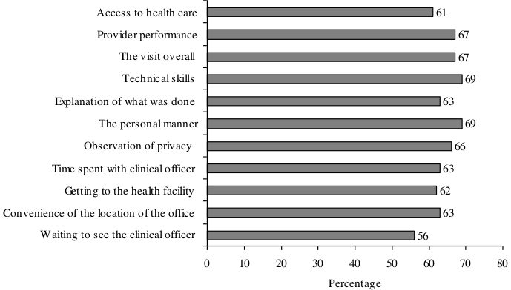Figure 1: Patient Engagement (from Karanja, 2012)

## Patient Centric Engagement

Patients have goals with respect to either improvement of their health condition or staying healthy. To achieve these goals either patient centered care or patient engagement or both must be embraced by the health facility/ Patient centered care is an all-round attention given to a patient health care needs from different perspectives such mental, emotional, spiritual and financial and the decisions made on a person’s healthcare are based on these perspectives (“What is patient-centered care?,” 2017).

Patient engagement involves the collaboration between the health worker and the patient to help improve his health (“What is Patient Engagement?,” 2016). This is because they desire to be participants in the decision-making process regarding their health. Evidently, technology can easily become the driving force behind these two dimensions because it is possible to capture with high level precision as they occur. Analytics automate a common CO behavior such as repeated prescription of a specific drug and share the same electronically with the patient or iterate through CO diary to identify a suitable time for patient appointment with the CO (Byers, 2017).

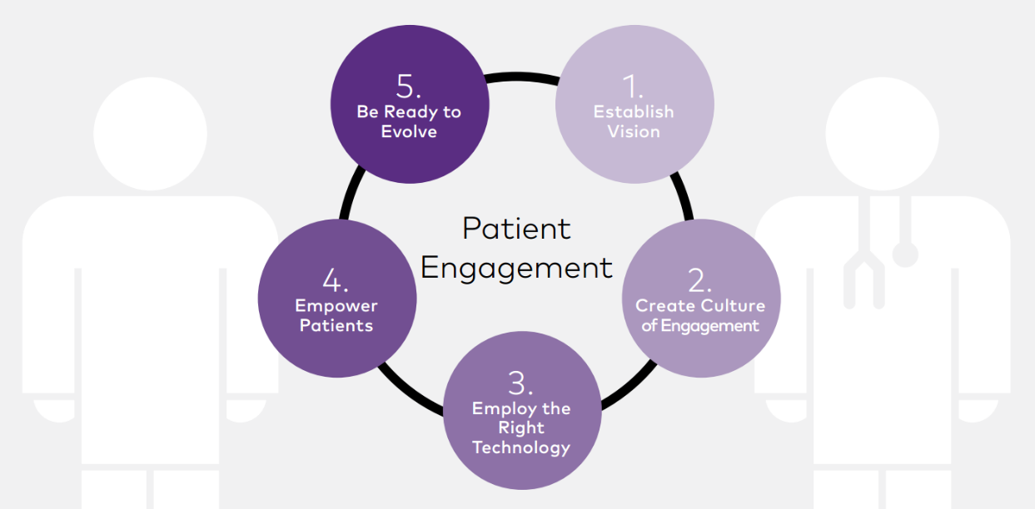

Figure 2: Patient Engagement (from “ReferralMD,” 2018)

## Leveraging on Bluetooth Low Energy (BLE) Beacons at health facilities

Health facilities present an ideal place to implement Bluetooth technology. visitors to health facilities are seeking medical attention that is administered promptly. In fact, every minute count and the longer a patient takes to get treated the higher the risk of succumbing to his illness. Thus, earlier this year a hospital in Japan, Nagoya, University Hospital, launched a proof of concept (POC) to show case the use of BLE beacons(Swedberg, 2018). Firstly, they wanted to find out the movement of their staff members to understand where they go, how often they interact with the patients and for how long. Secondly, they wanted to have the vital signs of patients transmitted together with their identity and location. Lastly, quantitatively measure workload of staff, provide support in areas where staff are overloaded and in so doing, give proper care to patients.

The Mercy Hospital in Cincinnati, USA uses BLE beacons to help patients navigate through the hospital. The hospital wanted a better way for patients and visitors to find their way around the hospital. They already had attendants stationed at points to give direction and they wanted a way to have visitors and patients navigate around the hospital by themselves. They installed 280 beacons around the hospital, a wayfinding mobile application and a web-based map. As visitors arrived at the hospital they would be welcomed and asked their direction. When visitors arrived by vehicle, at the parking lot, the app would ask if they would like to save the vehicle’s location. The system went live at the hospital in April 2017 (Swedberg, 2017).

## BLE Beacons Techniques and Technologies

A BLE beacon is a radio transmitter. It functions by utilizing radio frequency to transmit a low energy signal that other Bluetooth enabled devices can detect(Nick, 2015). Bluetooth is globally accepted and is found on a variety of devices such as phone, laptops, speakers, headphone and game consoles. Devices connect with each other when near each other through a process called pairing. Once the devices are paired a full duplex communication is established thereby allowing transfer of data and voice over a short range. Its short range can be anywhere between 1 meter to 70 meters although new models can transmit their signal up to 500metres away and are more suitable for indoor positioning. Bluetooth low energy are a superior version of the standard Bluetooth and are power consumption friendly, compact, affordable and less complex.

Beacon operates in two different modes. It is a device that broadcast non-connectable advertising packets that carry small pieces of information to nearby devices. Also, or one that transmits connectable advertisements that allows a customer to connect and if authorized, allows them to update the URL content(Chester, 2016). Therefore, a beacon acts both as a master and a slave. As a slave the beacon will transmit advertising information and wait for connection request from an interested master device. And as a master device, it will listen for advertising information and choose whether to connect to those slaves. At the end the goal is to achieve pairing between appropriate partner devices.

Two Protocols exist for BLE beacons. Apple’s iBeacon released in 2013 and is strictly for IOS devices while Google’s beacon, Eddystone, was released in 2015 and it is open source for both Android and IOS devices. Because of its open source nature, Eddystone has many more companies that uses its specification to manufacture their beacons. Also, it includes four types of data described by three frames which are

* Eddystone-URL for broadcasting URL addresses
* Eddystone-UID for broadcasting beacons IDs
* Eddystone-TLM for beacon telemetry.
* Eddystone-EID for security.

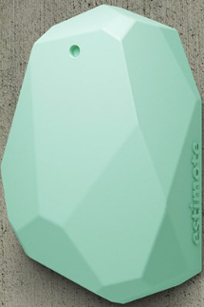

Figure 3: A BLE Beacon (from “Eddystone Beacon,” n.d.)

Each frame is an advertising packet of up to a maximum 31 byte payload as described in the 4.2 BLE Bluetooth specification(“Bluetooth 4.2 Specification,” 2014)

Validation tests are carried out on the beacon. So, test tools such as the Eddystone Validator is available on github (*eddystone*, n.d.-a) to ascertain the format of the frames while Eddystone URL, config validator is used to test the seamless integration between the physical web application and the Eddystone-URL configuration application (*eddystone*, n.d.-b). These

## Alternative Technologies to BLE Beacons in reducing patient wait time

BLE beacons are one of the many different methods of transmitting a signal. Others include Global Positioning System (GPS), Wireless Fidelity (Wi-Fi), Radio Frequency Identification (RFID), Quick Response (QR) code, Long Term Evolution (LTE) Direct.

### Global Positioning System (GPS)

GPS is a satellite-based navigation system and precise positioning tool. The first satellite was launched in 1978 and today that are at least 24 satellites orbiting about 20000km above the earth’s surface in a way that they surround the earth’s surface. It works by relying on signals from multiple satellites through a process known as triangulation to determine a physical location with an accuracy of about 10 meters working well when there is a direct line of sight to at least four would satellites. Thus, it is more ideal for outdoor location positioning as indoor location positioning require it to be combined with the Wi-Fi

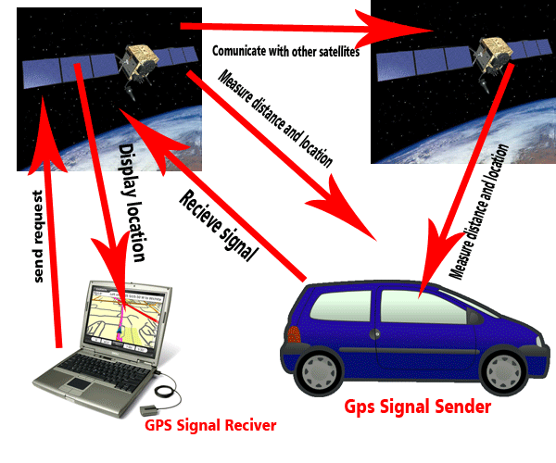

Figure 4: Global Position System (from Mahajan, 2015)

### Wireless Fidelity (Wi-Fi)

Wi-Fi is a technology that makes use of radio frequency to allow for network connectivity. Devices that have inbuilt Wi-Fi receivers such as laptops, phone, tablets, printers pick the radio frequency signals from a Wi-Fi adapter. In effect, this adapter creates a small wireless local area network (WLAN) and devices connected to it can access resources such as printers, documents and the internet. Again, the range covered by a Wi-Fi transmitter is about a radius of 20 meters in the line on sight making it a suitable candidate for indoor positioning. Also, easy adoption of Wi-fi as it allows as many users to connect to it by simply keying in a password on their device. The disadvantage being high power consumption. It requires another layer of security management as it does not ask users for their permission and does not require user intervention other than to completely disable Wi-Fi in case it is not required.

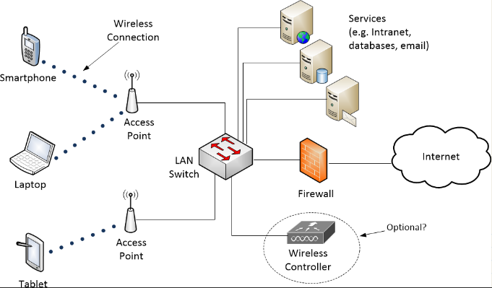

Figure 5: Wi-Fi Wireless LAN (from Bowden, 2015)

### Radio Frequency Identification (RFID)

Radio Frequency Identification is wireless communication system that that uses radio waves to read and capture information stored in a tag (“What is RFID?,” n.d.). It incorporates use of electromagnetic fields in a portion of radio frequency of the electromagnetic spectrum to identify objects with tags on them. An RFID is made up of three components a transponder, and interrogator and a RFID tag. The tag holds about 2MB of dat. Thus, when the reader sends a radio signal out the tag is activated, it sends data to the reader’s antennae. The additional devices such as the reader, reader control, tags and application software add to the cost of implementing such a solution. Also, RFID requires specific frequencies that are not factored in mobile devices making use of mobiles and RFID impracticable.

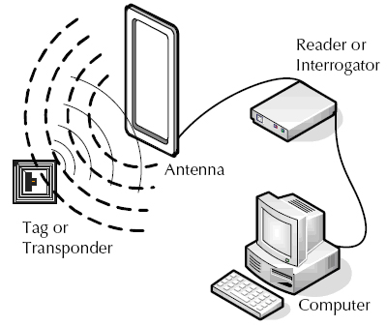

Figure 6: How RFID works (from “What is RFID?,” n.d.)

### Quick Response (QR) code

Quick Response is a 2D barcode that is provides access to information through use of a smartphone. This works by a smartphone user opening a QR code reader and pointing the camera to the graphic code. The reader interprets the code and triggers a call to action such as an application download or viewing an image. The use of QR requires use of a QR reader that has to be downloaded. Additionally, the amount of time taken in scanning the code accurately and eventually getting a landing page can be a hinderance to its use in hospitals.



Figure 7: QR code (from Rouse, n.d.)

### Long Term Evolution (LTE) Direct

LTE Direct is the autonomous long-distance Device to Device (D2D) protocol introduced in 3rd Generation Partnership Project Release(3GPP) 12 specification by QUALCOMM. LTE enabled mobile devices and apps discover and directly communicate with nearby LTE devices (Rao, 2017). Notably, these devices can connect to 1000 devices and have a coverage of a radius of 500 meters without the need of the base transceiver station (BTS). Thus, taking direct communication to the next level of communication beyond what Wi-Fi and Bluetooth are currently offering. Since it is the new kid on the block with its announcement in 2011 and standardization done in 2013, mobile devices released after this date will most likely be LTE enabled. This may not account for more than one third of the mobile phones currently in the market. Even so, the structures required to support this technology, may not be in place rendering it useless for the time being.

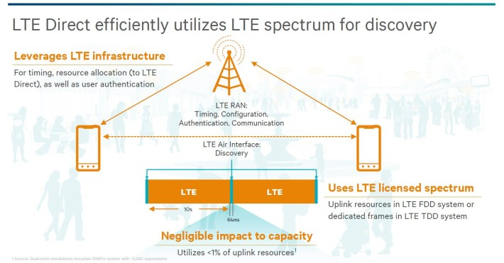Figure 8: LTE Direct (from Triggs, 2015)

## The Best Approach for BLE Beacons Implementation using Tools, Techniques and Methodologies of Similar Systems

Agile Methodology is the ideal approach to developing and implementing an improved patient experience using beacons. Firstly, this approach enables customer participation and together with the development team a product is created that evolves over time. Secondly, a project of this magnitude must be broken down into manageable tasks to address priority areas such as the outpatient facility of the hospital, promote adaptive planning, evolutionary development, early delivery and continuous improvement (“Agile scrum Methodology for Mobile Apps,” 2016). Thirdly, the constant changing technology and user requirements dictate that a methodology that embraces dynamism and manages turbulent environments. Lastly, is the rollout of the solution in phases thus keeping costs to a minimum while seeking buy in from stakeholders such as patients, hospital staff and hospital management.

Successful web and mobile application development have used a process planning methodology. This process planning models had traditionally been referred to as the software development life cycle (ISO/IEC 12207:2017) and was akin to the waterfall model. In comparison, modern models that ensure project consistency and completeness while keeping in tandem with the ever-changing needs of the customer, have been suggested when developing these applications such as the web development life cycle(French, 1970) and mobile development life cycle (“Agile scrum Methodology for Mobile Apps,” 2016). These methodologies are like SDLC and are iterative with user participation in focus. The phases include discovery, exploration, refinement, production, implementation, launch and maintenance (K., Landay, & Hong, 2003, ch 5).

Web applications that have been developed are expected to undergo an efficacious testing exercise. Rigorous testing of web application was done due to the huge population size that interacted with the application, its heterogeneous nature, concurrent transaction processing and the fact that such applications are multi-tiered. Therefore, challenges have been encountered while carrying out tests on web applications such as state navigation, transition navigation, web server error messages, asynchronous and stateful behavior (Arora & Sinha, 2012). While considering these challenges, techniques used to test these applications have included the White Box and Black box testing (Arora & Sinha, 2012, p3)

Database driven web and mobile e-commerce application are required to be highly responsive to requests made by users. Web pages are rendered based on ever changing content obtained from the database. The process entails request being made by a client or browser, this request is then passed to the webserver then application server and finally the database. In addition to the various servers are firewalls, proxy servers and transport layers that such a request goes through before it reaches its destination. In considering performance, developers have made sure that web page response times are under 200ms (Oreilly, 2009) by request made to the web server as well as carry out data processing at the data layer instead of the business layer.

Mobile enterprise application development requires the use of tools and techniques that are have a cross platform paradigm. Such complex applications use an array of components such as HTML 5, javascript, AJAX, JSON, CSS3. Also, access to large database handling, API functionality of the underlying operating system is required. Inevitably, cross platform framework such as phonegap are used because it incorporates HTML5 techniques, natively coded containers as well as can incorporate proprietary APIs to generate a solution that work across different operating systems (Wolf & Huffstadt, 2013)

A successful web or mobile application must embrace modern ways of doing development, testing and deployment. The outcome of this process is a robust, highly responsive application. In this regard appropriate tools, techniques and methodologies such as phonegap, WebML and prototyping are used for planning, consistency and rapid application development.

In conclusion, the proposed application seeks to incorporate the described methodologies, tools and techniques to rapidly develop the outpatient health facility patient improvement solution and ensure that it has minimal response times, is usable and secure.

## Architectural Design of the patient improvement using beacons

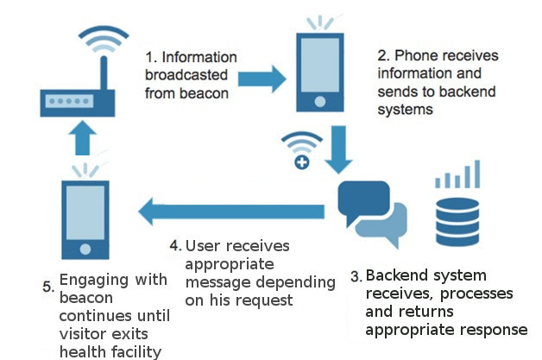The interaction between the visitor’s phone and the beacon is hown

Figure 9: Conceptual design of the system

# Research Methodology

## Introduction

The proposed solution shall be developed using an agile methodology. The success of this solution is dependent on interaction with the different stakeholders. So, this methodology is well suited as it allows for such interaction ensuring that feedback received is incorporated into the next release. A detailed functional and non-functional requirement describing the behavior of the system and constraints respectively had been included. The software and hardware tools that will be used to develop and operate the solution is described.

## Software Development Methodology

An Agile approach shall be used in the development of the application. This methodology relies on continuous collaboration between the software development team and stakeholders. In this case, the stakeholders are the visitors, doctors, nurses, support staff and health facility administration. So this approach includes, adaptive planning, evolutionary development, early delivery and continuous improvement the result being rapid and flexible response to change.

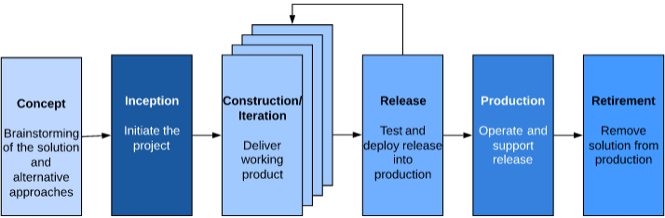Figure 10: Agile Software Development Methodology

There are six stages to realizing a working solution that include Conceptualization of the project, initating the project and requirement elicitation, construction and interation, testing and release solution into production, ue and support solution, retire solution once continued support becomes unrealistic.

### Conceptualization of the project

The developers and the product owner conceptualize the project. Together, the team explores the pros and cons of the solution to determine whether it is worthwhile doing, its impact on the stakeholders and benefits to the health facility. Alternative solutions are also tabled, and comparisons done to formulate a justification for the potential project. Also, a detailed feasibility analysis is carried out to establish the project viability and if it makes sense to invest in it.

### Inception phase

The use of BLE beacons to improve patient experience needs to be modelled. Thus, working with the stakeholders, a high-level model shall be developed that captures the initial requirements. As the stakeholder get a better understanding of the solution, the model will continually be improved to better understand the problem and the solution domain. Again, the development team identifies those who will undertake the development, software tools to be used and the initial architecture of the solution. And, the development environment is set up such as the workstation identification, software tools installation, working area identification and access to resources in the right way. Basically, the inception phase is for preparing the ground before actual work begins.

### Construction

The development of the solution shall commence at this stage. Firstly, the order of development is based on the priority of the functionality. Thus, a functionality with a higher priority is developed first. Secondly, emphasis is placed on delivery of high quality software and each iteration produces better working solution than the previous one. Thirdly, Tests are carried out rigorously to ensure each successful iteration. Finally, communication between the different stakeholders in improved and feedback cycle tightened. The construction phase shall ensure a solution that give patients a better healthcare service.

### Release

The release of the solution shall be deployed to the production environment. The solution by now has undergone several iterations during construction and detected bugs addressed. Additionally, user documentation has been prepared and training conducted for use of the solution. And, the production environment shall be setup with all the required software for deployment of the solution. As the release is being used, there shall be feedback from the stakeholders and these are forwarded to the development team for consideration during the next release.

### Production

The solution is in use while in production. During this time, issues that arise shall be addressed promptly so that the solution runs smoothly and gives a superior experience to the user. Production shall come to an end when support ends or when the solution is retired. Typically, this shall happen when there is a new release awaiting deployment to production.

### Retirement

The solution in production shall reach its end of life. Once this happens, it is decommissioned while ensuring minimal impact to business operations. While decommissioning the existing solution, a new solution shall replace the old one.

## Functional requirements

Functional requirements are the specific needs of the system that must be met. These are testable and represent the user’s expectation of the system. The following functional requirements shall address the business needs:-

### Beacon Frame Type Requirement

1. The system shall broadcast the appropriate frame type
2. Mandatory fields such as the beacon identifier, timestamp, beacon interval have been sent and are available in the frame body

### Beacon URL configuration Requirement

1. A compressed URL is broadcasted ant intervals and can trigger the launch of a web page
2. Different URLs are broadcasted for different activities

### Authentication Requirement

1. The system shall allow users to log in prior to accessing the application.
2. The Password required to access the application will expire periodically.
3. The system will send a temporary password to the user upon being created.
4. The system will lock out a user once the prescribed login attempts have been exceeded.

### Authorization Requirement

1. The system will have roles that give users limited access to data files.
2. The system will notify the administrator of new sign ups awaiting approvals.
3. The system menus will be displayed be based on user rights.

### New User Requirement

1. The system will allow users to sign up to use the application.
2. The system will capture additional information regarding the new user.
3. The system will request for such additional information once the user logs into the system for the first time.

### Existing User Requirement

1. The can login using his credentials
2. Ability to change password

### Patient request Requirement

1. Request to see a doctor
2. Request a doctor’s appointment

### Patient Preliminary Check Requirement

1. Patient receives results of BP, temperature and weight

### Payment Requirement

1. Launch payment channel while making payment
2. Provide various payment options
3. Generate an e-receipt
4. Update Cashier receipt register
5. Queue patient for next activity

### Queue broadcasting requirement

1. A ticket is issued to a patient waiting to see the doctor
2. A listing is obtained from a URL showing the position in the queue
3. An alert to inform patient that it is his turnd

### E-prescription requirement

1. A e-prescription is broadcasted to the patient phone together with the cost of the drugs
2. Payment of the drugs is done
3. The Pharmacy receives the purchase order for dispensing the drugs
4. Patient is alerted once drugs are ready for collection

### Survey requirement

A questionnaire presented to the patient to determine the quality of service offered

## Non-Functional Requirement

Non-functional requirement refers to the attributes that are constraints to the design of the system such as security, reliability, performance, maintainability, scalability, and usability. Although they are not addressing the needs of the user directly like functional requirements, they are as important because of ensuring usability and effectiveness of the entire system. The following non-functional requirements will be considered during the development of this solution: -

### Operational Requirement

1. The system should run on desktops and smartphones and tablets
2. The system should work on a Firefox, Opera, google Chrome and Internet Explorer browsers
3. The system be easily accessible on the hospital intranet.
4. The system should be available for download on smartphones and tablets.
5. The mobile application should interface with the medical record system and google cloud system to retrieve and store information.

### Performance Requirement

1. The system should support one million users.
2. The system should handle ten thousand requests daily.
3. The system should have a fail-over mechanism, with a maximum downtime of 30 minutes before all services are restored.
4. The system should be available 24 hours, throughout 7 days of the week or configurable time week.
5. It is expected that the volumes will grow by as much as 20% over the next 5years.

### Security Requirement

1. The system should allow users access to the functionalities that have been granted to them.
2. The system should ensure that a single user is entitled to only perform a combination of functions as allowed by the segregation of duties principle.
3. The system should allow for dynamic profile creation such that roles can be re-allocated and new profiles created as needs arise.
4. The system should restrict approval of user to the administrator.
5. The system should generate audit trail logs.
6. The system should encrypt all electronic information that is stored or transmitted.

### Cultural and Political requirement

1. The system should have functionalities to provide user identification for tasks performed by each user and give a status of pending items as well as provide a report of completed tasks.
2. The system should protect personal information in compliance with the Data Protection Act.
3. Document and data retention should adhere to regulator and country’s record retention schedules and in any case, data for active transactions should be available regardless of age.

## System Implementation methods and tools

### Software Tools

1. **Operating System**: Windows 7 – It was select because it is a popular operating System from Microsoft and it is available on majority of desktops and laptops. All applications will run on it.
2. **Web Programming Language**: PHP – It was select because it is easy to use, and it has frameworks such as Laravel that speed up the development process of the web application.
3. **Mobile App Development**: Android Application Framework – it was selected because it is a complete suite of components that are used to construct android applications. Android applications can run on android phones which are a majority in the country.
4. **Web Framework**: Laravel – was selected because it will speed up development of the application. It is an open source web application framework and inversion control container that utilizes the model-view-controller design pattern. It is used to construct applications that run on a Java platform.
5. **Database**: PostgresSQL was selected because it is a high-level database that is an open source object-relational database. It does not have restrictions on licensing. Being an object database, it has JSON functions that allow it to store and retrieve JSON objects.
6. **Documentatio**n: Microsoft Word 2013 – it was selected because it is an easy to use word processing editor that has in build styles. It shall be used to create user, administration and technical manuals and guides.
7. **Version Control**: Git – It was selected because it is a version control system that tracks changes to computer files. It can keep track of changes while offline because of it distributed nature. It shall be used to backup and keep track of changes to source code.
8. **Design Tool**: StarUML – it was selected because it is a CASE tool for designing UML diagrams. It shall be used for designing use cases, entity models and sequence diagrams.
9. **UI wireframe**: Pencil – It was select because it is an easy to use open source GUI prototyping tool source for designing web and mobile user interfaces. It shall be used to design mobile and web application interfaces.
10. **Webserver**: Apache – It was selected because it is a simple andeasy to use webserver for deploying php web applications. The hospital information system /us///shall be deployed on this server.
11. **Browser**: Chrome Version 50 and above, FireFox 50 and above. These browsers were selected because they are popular easy to use browsers. The web application shall run on this browser.
12. **Emulator**: GenyMotion – It was selected because it is a light weight emulator that comes as a chrome extension. It shall be used to test the mobile application.
13. **Build and Deployment**: Gradle – is an automated build tool for packaging and deploying android applications. It shall be used make the build process easy through identification of the dependencies and incorporation of the same into the final package, specification, execution and reporting of unit tests carried out, release management and issue tracking.
14. Google beacon dashboard to be used for registering , controlling and monitoring beacons.

### Hardware Tools

1. Intel Duo Core 1.3ghz PC
2. 4Gb RAM
3. 20Gb Hard Disk
4. Universal 2016 Bluetooth Ibeacon EddyStone Module with Power Button
5. Android 5.1/smartphone

The next step after construction of the software, shall be the deployment and implementation. Deployment shall involve copying the relevant files to the web server. Implementation shall require the webserver to be started up so that the web pages are loaded when a request is made.

## Deliverables

A fully functional web application that launch either on a mobile device or desktop computer on tapping or clicking the received URL. It shall contain a security, administration, patient records, prescription, payments module. A beacon shall be used to broadcast the URL received from google cloud. Updates will be in real-time, so that the different stakeholders have the information at their fingertips. In addition to the application are documentation such as test scripts, user guide, administrator guide, technical guide, setup installation and configuration manual, database scripts and troubleshooting guides.

# Analysis and Design

## Introduction

This chapter focuses on the analysis, design and architecture of the proposed system centered on the user requirements and methodologies proposed in the previous chapter. This was achieved through use case diagrams and their detailed descriptions, System Sequence Diagrams, Design Class Diagrams, Entity relationship Diagrams and Security Design.

**References**

2013 Kenya Household Health Expenditure and Utilisation Survey. (2014).

Agile Methodology in Mobile Application Development. (n.d.). Retrieved July 18, 2018, from https://project-management.com/agile-methodology-in-mobile-application-development/

Agile scrum Methodology for Mobile Apps | Agile SDLC model. (2016, August 31). Retrieved from https://www.queppelin.com/2016/08/agile-methodologies-for-mobile-application-development/

Android versions market share 2018. (n.d.). Retrieved July 30, 2018, from https://www.statista.com/statistics/271774/share-of-android-platforms-on-mobile-devices-with-android-os/

Arora, A., & Sinha, M. (2012). Web Application Testing: A Review on Techniques, Tools and State of Art. ISS N, 3(2), 6.

Bowden, N. (2015, June 13). Module-1: What is Wi-Fi? – Wi-Fi For Beginners. Retrieved from http://wififorbeginners.com/category/podcast/module-1/

Budget Statement FY 2018/19. (2018) (pp. p23-24).

Byers, J. (2017, February 27). HIMSS17: How tech tools can aim for better patient experience. Retrieved from https://www.healthcaredive.com/news/himss17-patient-experience/436813/

Çabuk, U. C., Kanakis, G., & Dalkılıç, F. (2016). LTE Direct as a Device-to-Device Network Technology: Use Cases and Security. IJARCCE, 5(7), 401–406. https://doi.org/10.17148/IJARCCE.2016.5779

Changalwa, K. (2016, December 15). The Contestation of Rights In The Health Sector In Kenya: The Right To Health Vis A Vis Labour Rights. Retrieved from http://knchr.org/Blogs/tabid/1256/ArticleID/5/The-Contestation-of-Rights-In-The-Health-Sector-In-Kenya-The-Right-To-Health-Vis-A-Vis-Labour-Rights.aspx

Chester, K. (2016). Implementing EddystoneTM Bluetooth® Smart Beacons Using the TI BLE-Stack. Retrieved from http://www.ti.com/lit/an/swra491a/swra491a.pdf

Daniş, F. S., & Cemgil, A. T. (2017). Model-Based Localization and Tracking Using Bluetooth Low-Energy Beacons. Sensors (Basel, Switzerland), 17(11). https://doi.org/10.3390/s17112484

eddystone: Specification for Eddystone, an open beacon format from Google. (n.d.-a). C, Google. Retrieved from https://github.com/google/eddystone (Original work published 2015)

eddystone: Specification for Eddystone, an open beacon format from Google. (n.d.-b). C, Google. Retrieved from https://github.com/google/eddystone (Original work published 2015)

French, A. M. (1970). Web Development Life Cycle: A New Methodology for Developing Web Applications. The Journal of Internet Banking and Commerce, 16(2), 1–11.

Google Presents Its New Beacon System Eddystone - New Standard Is. (n.d.). Retrieved July 5, 2018, from https://www.infsoft.com/blog-en/articleid/33/google-presents-its-new-beacon-system-eddystone-new-standard-is-fully-compatible-with-all-solutions-by-infsoft#/images/2

Govt in new drive to increase NHIF membership. (n.d.). Retrieved from https://www.nation.co.ke/news/Govt-in-new-drive-to-increase-NHIF-membership/1056-4305068-vxkvnlz/index.html

Han, T., & Ding, L. (2017). Design and implementation of Bluetooth beacon in mobile payment system (p. 020019). https://doi.org/10.1063/1.4992836

Hasan, M., & Haque, M. (2016). Mobile Application Development Approaches: Recommendation for E-commerce Enterprises.

Improving Health Care for Kenya’s Poor. (2014, October 28). [Text/HTML]. http://www.worldbank.org/en/news/feature/2014/10/28/improving-healthcare-for-kenyas-poor

ISO/IEC/IEEE 12207:2017 - Systems and software engineering -- Software life cycle processes. (2017, November). Retrieved July 15, 2018, from https://www.iso.org/standard/63712.html

K., van D. (Douglas, Landay, J. A., & Hong, J. I. (2003). The Design of Sites: Patterns, Principles, and Processes for Crafting a Customer-centered Web Experience. Addison-Wesley Professional.

Karanja, L. M. (2012). Patients’ ratings of the quality of their outpatient visit to clinical officers in Kenya. Ethopian Journal Health Sciences, Vol. 22, No. 3, 8.

Kenya’s mobile penetration hits 88 per cent. (2015). Retrieved July 3, 2018, from http://www.ca.go.ke/index.php/what-we-do/94-news/366-kenya-s-mobile-penetration-hits-88-per-cent

Kihuba, E., Gathara, D., Mwinga, S., Mulaku, M., Kosgei, R., Mogoa, W., … English, M. (2014). Assessing the ability of health information systems in hospitals to support evidence-informed decisions in Kenya. Global Health Action, 7. https://doi.org/10.3402/gha.v7.24859

Legacy Core Specifications | Bluetooth Technology Website. (2014). Retrieved July 29, 2018, from https://www.bluetooth.com/specifications/bluetooth-core-specification/legacy-specifications

M. Amen, B., M. Mahmood, S., & Lu, J. (2015). Mobile Application Testing Matrix and Challenges (pp. 27–40). Academy & Industry Research Collaboration Center (AIRCC). https://doi.org/10.5121/csit.2015.50403

Mahajan, M. (2015, May 9). What Is Global Positioning System (GPS) ,Its Uses %%. Retrieved from https://tectrick.org/global-positioning-system-gps/

Munge, J. (2017, January 9). Embracing digital healthcare in Kenya. Retrieved from https://www.standardmedia.co.ke/article/2000229164/embracing-digital-healthcare-in-kenya

National Hospital Insurance Fund. (n.d.). Retrieved July 3, 2018, from http://www.nhif.or.ke/healthinsurance/outpatientServices

Nick. (2015). The Hitchhikers Guide to iBeacon Hardware: A Comprehensive Report by Aislelabs. Retrieved from https://www.aislelabs.com/reports/beacon-guide/

Rao, R. (2017, December 9). LTE Direct to Revolutionize the Cellular Internet of Things (CIoT). Retrieved from https://www.linkedin.com/pulse/lte-direct-revolutionize-cellular-internet-things-ciot-rajashree-rao

Rouse, M. (n.d.). What is QR code (quick response code)? - Definition from WhatIs.com. Retrieved from https://whatis.techtarget.com/definition/QR-code-quick-response-code

Speech by His Excellency Hon. Uhuru Kenyatta, C.G.H., President And Commander In Chief Of The Defence Forces Of The Republic Of Kenya During The 2017 Jamhuri Day Celebrations At The Moi International Sports Centre, Kasarani On 12th December, 2017 – Presidency. (2017, December). Retrieved July 1, 2018, from http://www.president.go.ke/2017/12/12/speech-by-his-excellency-hon-uhuru-kenyatta-c-g-h-president-and-commander-in-chief-of-the-defence-forces-of-the-republic-of-kenya-during-the-2017-jamhuri-day-celebrations-at-the-moi-international/

Sustainable Development Goals | UNDP. (2015). Retrieved July 2, 2018, from http://www.undp.org/content/undp/en/home/sustainable-development-goals.html

Swedberg, C. (2017, May 5). Hospital Combines Kiosks With BLE App to Help Patients Navigate - 2017-05-05 - Page 1 - RFID Journal. Retrieved July 6, 2018, from http://www.rfidjournal.com/articles/view?16028#back-from-modal

Swedberg, C. (2018, March 5). BLE Beacons Tested in Japanese Hospitals to Track Patient, Staff Interaction - IOT Journal. Retrieved July 6, 2018, from http://www.iotjournal.com/articles/view?17295

Technology will be major driver for Big Four plan, President Kenyatta says – Presidency. (2018, February 27). Retrieved July 4, 2018, from http://www.president.go.ke/2018/02/27/technology-will-be-major-driver-for-big-four-plan-president-kenyatta-says/

Top 13 Healthcare Technology Innovations of 2018 - ReferralMD Software. (2018, January 2). Retrieved from https://getreferralmd.com/2018/01/future-healthcare-technology-advancements-2018/

Triggs, R. (2015, May 21). LTE Direct smartphones could improve spectrum utilization. Retrieved July 6, 2018, from https://www.androidauthority.com/qualcomm-lte-direct-610209/

What is Patient Engagement? (2016, April 27). Retrieved from https://www.himss.org/library/patient-engagement-toolkit

What is patient-centered care? (2017, January 1). Retrieved from https://catalyst.nejm.org/what-is-patient-centered-care/

What is RFID? (n.d.). Retrieved from https://www.epc-rfid.info/rfid

Wolf, F., & Huffstadt, K. (2013). Mobile Enterprise Application Development - a Cross-Platform Framework, 1(1), 8.

**2018**

**Project Supervision Sheet**

**Student No**: ______________ **Student Name: ___________________________**

**Supervisor:** ____________________________________________

|  |  |  |  |
| --- | --- | --- | --- |
| **Date** | **Comment** | **Next Meeting** | **Signed: Supervisor** |
|  |  |  |  |
|  |  |  |  |
|  |  |  |  |
|  |  |  |  |
|  |  |  |  |
|  |  |  |  |
|  |  |  |  |
|  |  |  |  |
|  |  |  |  |
|  |  |  |  |

**\*This form must be signed a minimum of 8 times in order to qualify for the final presentation.**